SET A
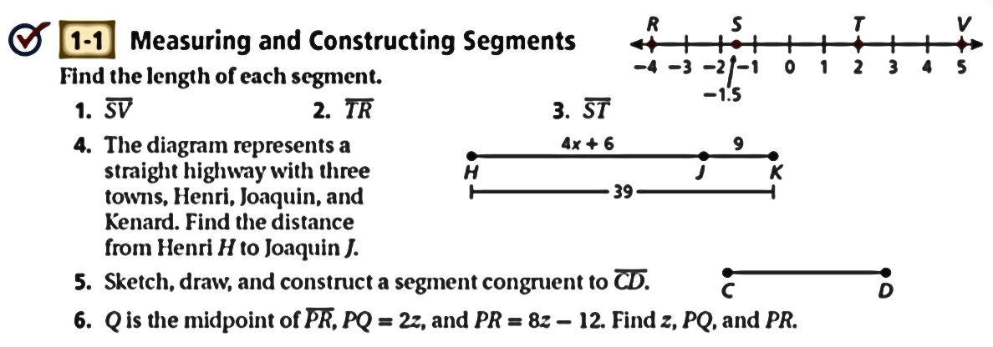

SET B
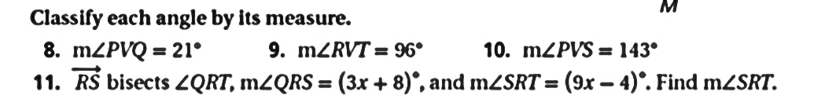

SET C
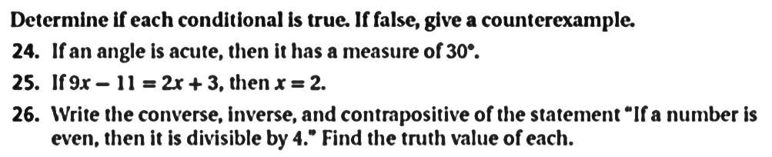

SET D
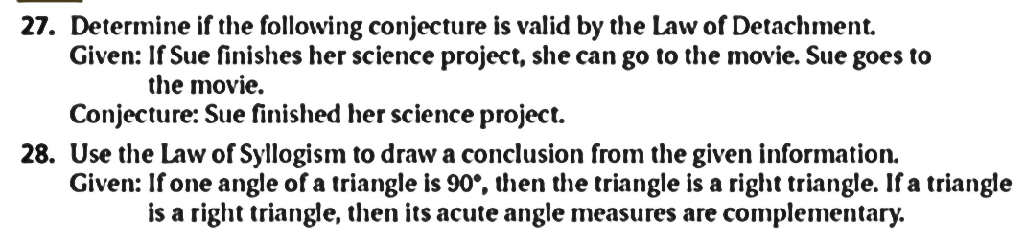
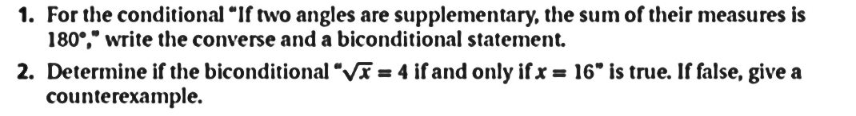

SET E
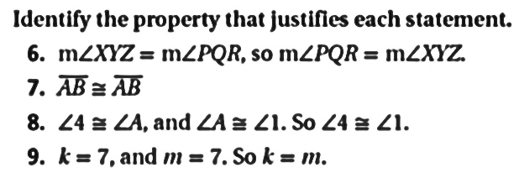

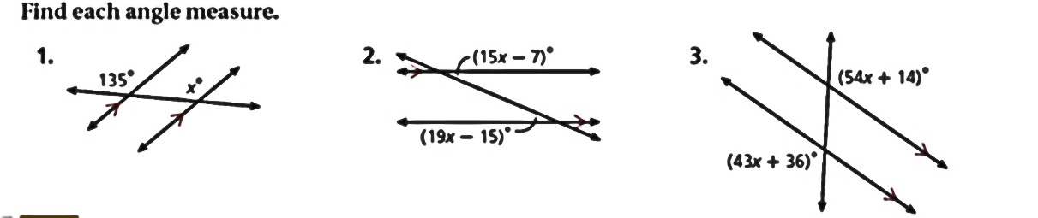

SET F
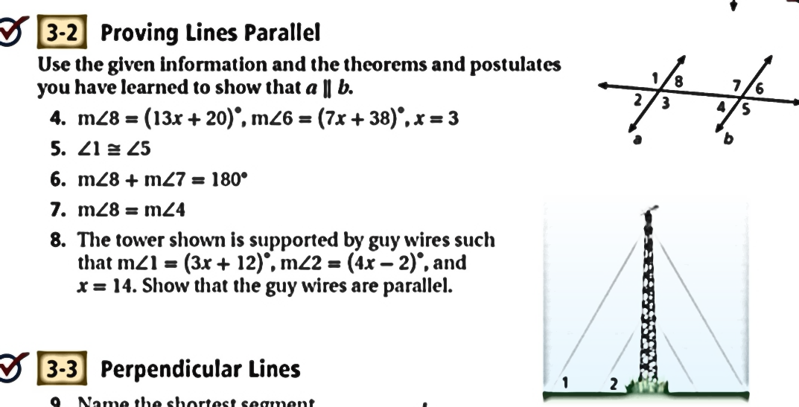

SET G
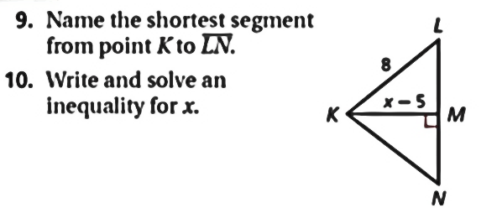

SET H
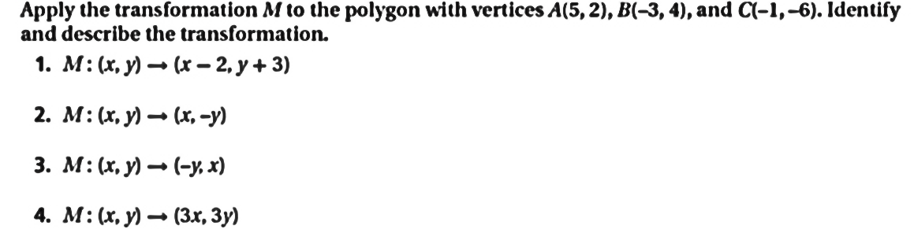

SET I
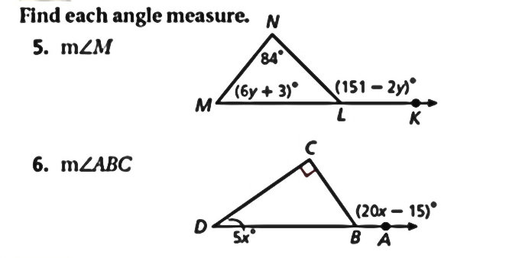

SET J

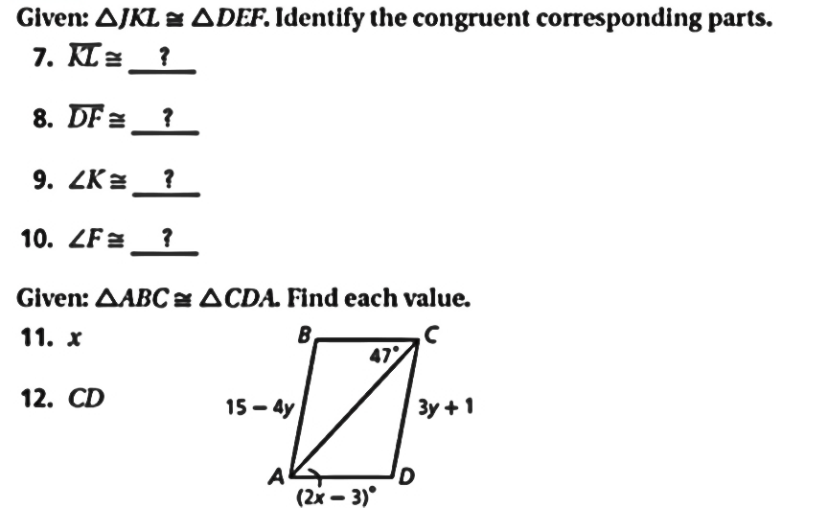

SET K
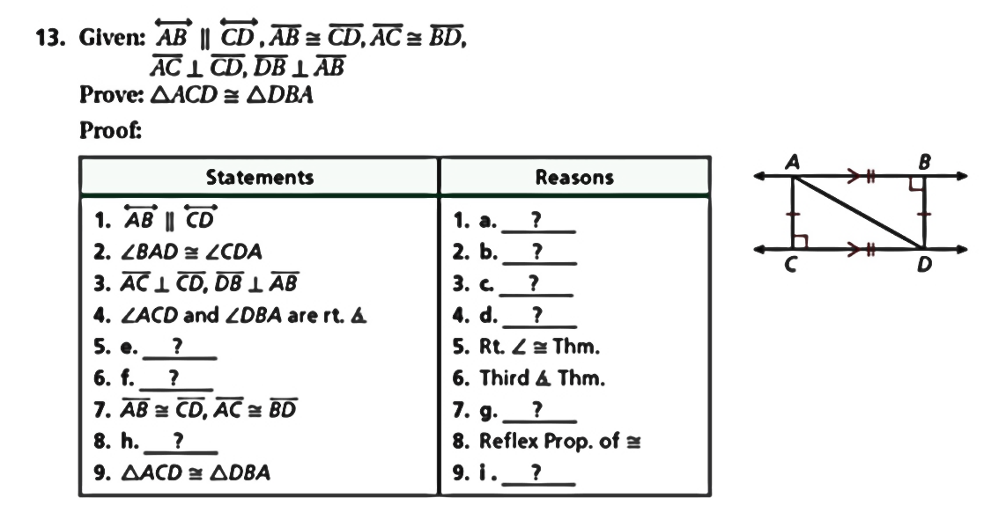
SET L
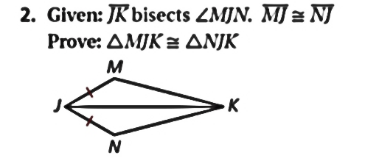

SET M
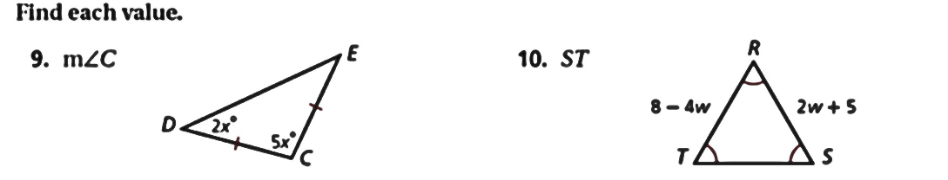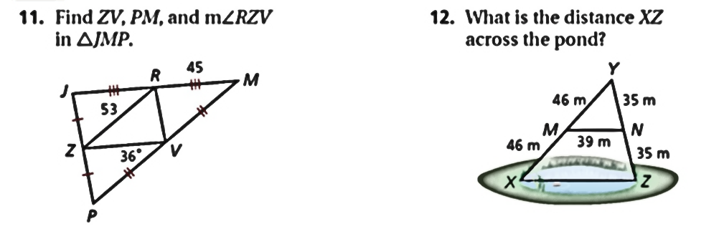
SET N
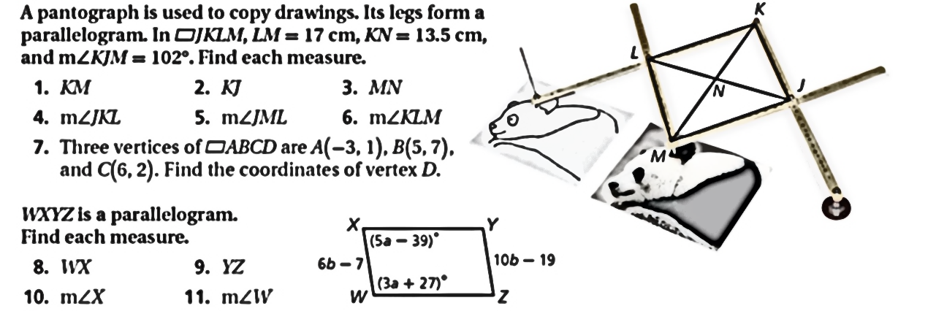

SET O
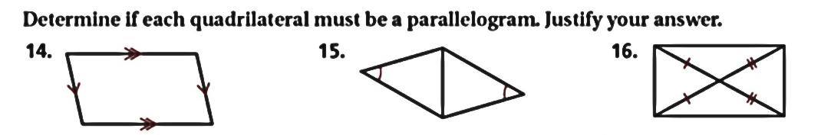

SET P
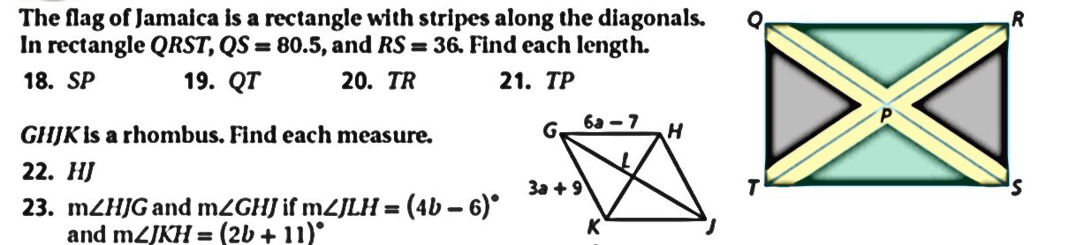

SET Q 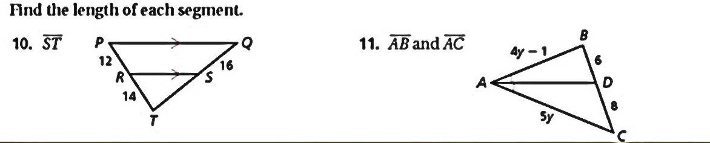

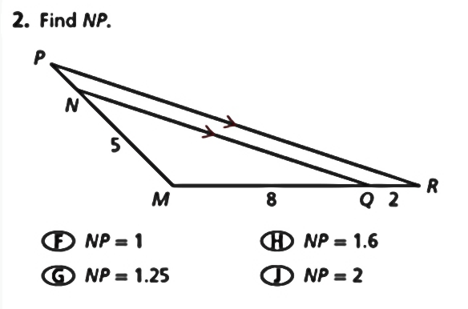
SET R
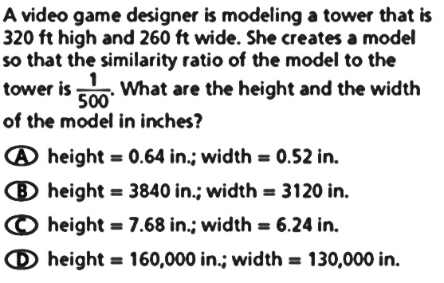

SET S
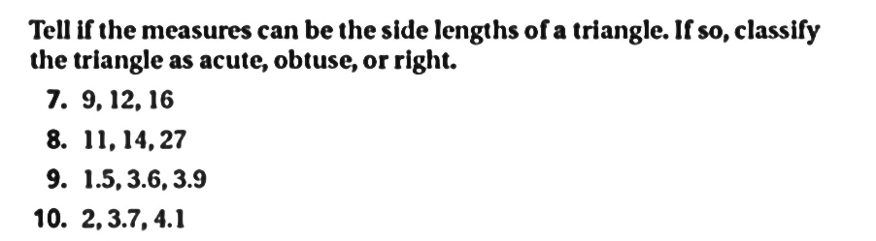

SET T
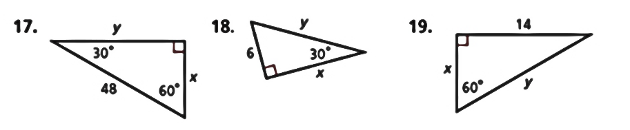

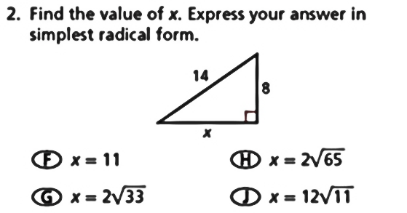
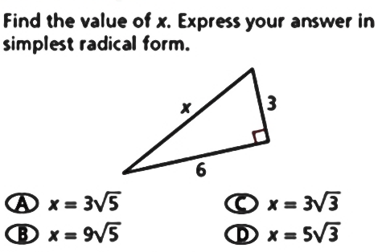

SET U
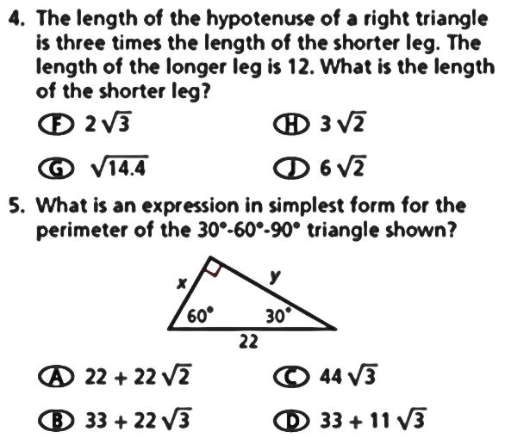

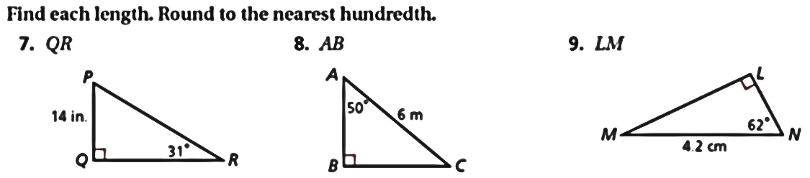

SET V
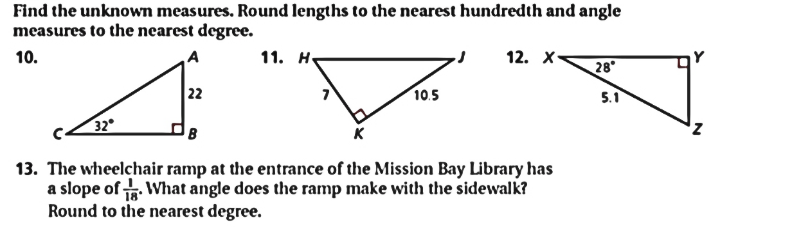

SET W
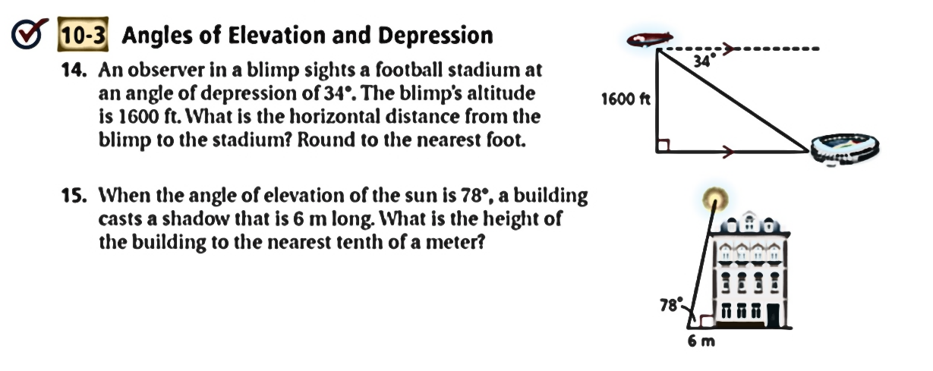

SET X
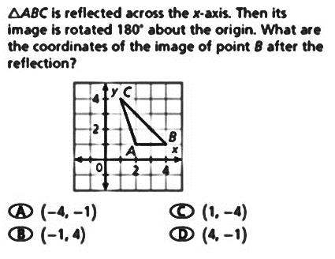
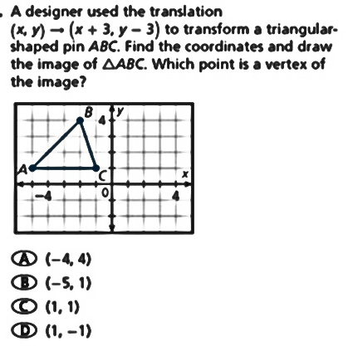

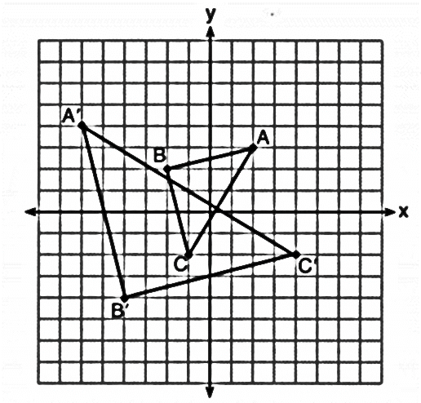
Directions: Describe the sequence of transformations.
‘
‘
‘

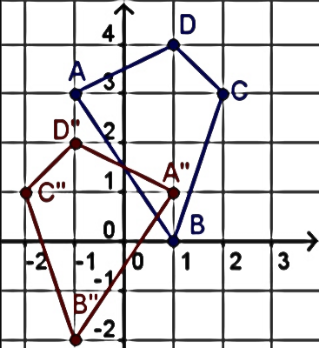
3) 4) (x, y) → ‘’(y, x – 3) 6)

5) A(3, 2) $→$ A’(5, 2) → A’’(2, 5)
B(–2, –1) → B’(0, –1) → B’’( –1, 0)

SET Y

1) If A(3, –2) is reflected over the x-axis and then translated 3 units left, what is A’’?

2) If B(4, 5) and C(–2, –1) is transformed to B’(5, –4) and C’(–1, 2), what transformation has occurred?

3) If R’(–3, 1) has been translated using the rule (x, y) → ‘(x – 3, y + 2), what is the pre-image, R?

4) If M(4, –2) and J(–3, 1) is horizontally shrunk by a scale factor of ½, what is J’?

5) What line has A(3, 5) reflected over if A’(3, –3)?

SET Z

1) What is A’ if A has been dilated by a scale factor 2) What is B’ if B has been rotated 90ᴼ CW about
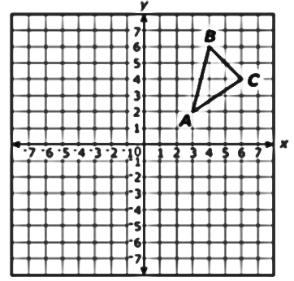
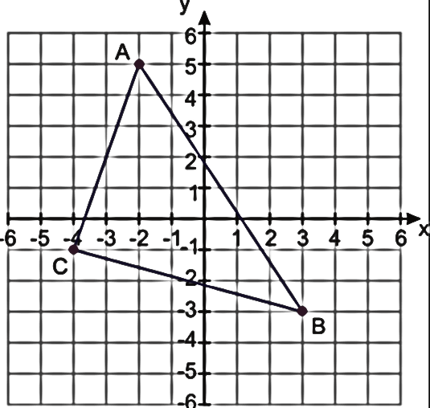
of ½ about the center (–2, 1)? Point A?

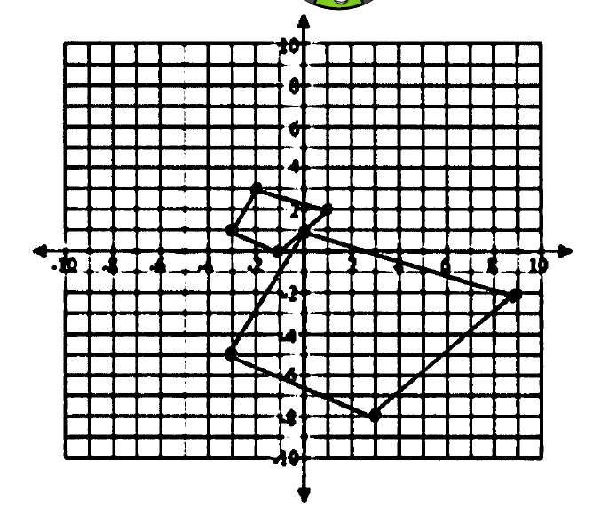

3) In the figure to the right, what is the scale factor
of dilation in this graph?

4) In the figure to the right, what is the center of the dilation?

5) A segment has vertices at G (6, 7) and H (3, 2). Which transformation would produce an image with
vertices G’ (-6, -7) and H’(-3, -2)?

6) A triangle has vertices at A (-2, 2), B (-1, 2) and C (-1, 4). Which transformation would produce an image with
vertices A’(-6, 2), B’(-3, 2) and C’(-3, 4)?

