SOHCAHTOA Missing Sides Geometry

Directions: Write the trigonometric ratio as a fraction and as a decimal rounded to the nearest hundredth.
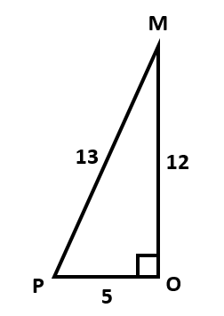
1) sin P 2) cos M 3) tan P

4) cos P 5) sin M 6) tan M

Directions: Use your calculator to find each trigonometric ratio to the nearest tenth.
7) cos 25ᴼ 8) tan 30ᴼ 9) sin 30ᴼ 10) cos 45ᴼ

Directions: Find each length. Round to the nearest hundredth.
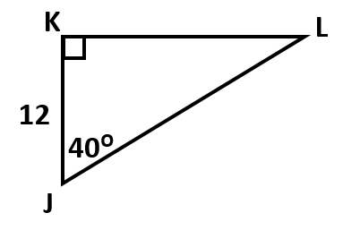
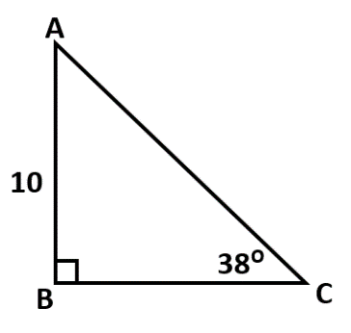
11) AC & BC 12) KL & JL

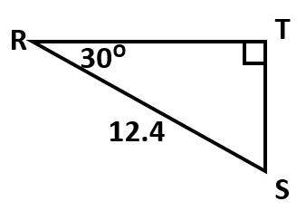
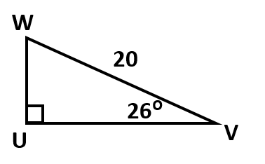
13) WU & UV 14) RT & TS

Directions: Draw a right triangle to represent each trigonometric ratio. Then, find the missing side.
15) sin A = $\frac{3}{5}$ 16) cos B = $\frac{6}{10}$

17) tan C = $\frac{5}{12}$ 18) sin D = $\frac{24}{26}$

Directions: Draw a triangle to represent the given situation. Then, find each missing side.
19) M, O, and N are the vertices of a right triangle. Angle M is 50ᴼ & MN = 20. MN is the hypotenuse. What is MO to the nearest tenth?

20) J, K, and L are the vertices of a right triangle. Angle J is 20ᴼ. KL = 12. If JK is a leg, what is JK to the nearest hundredth?

21) A, B, and C are the vertices of a right triangle. Angle C is 45ᴼ and AB = 30. If CB is a leg, what is the
exact length of AC?

