Sine/Cosine Relationships HW Name: _________________________________
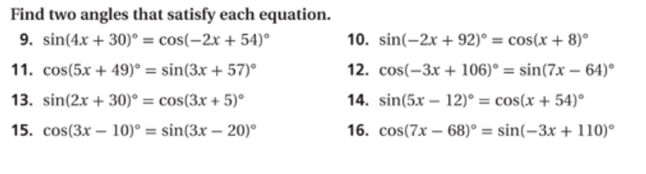
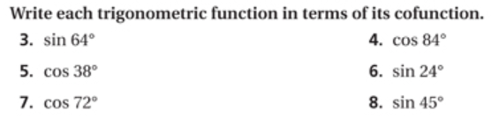
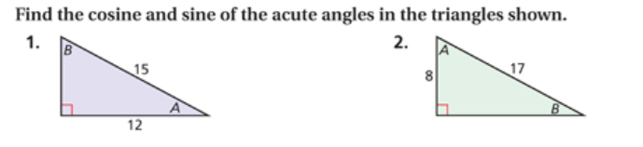
Date: ________ Period: _________

